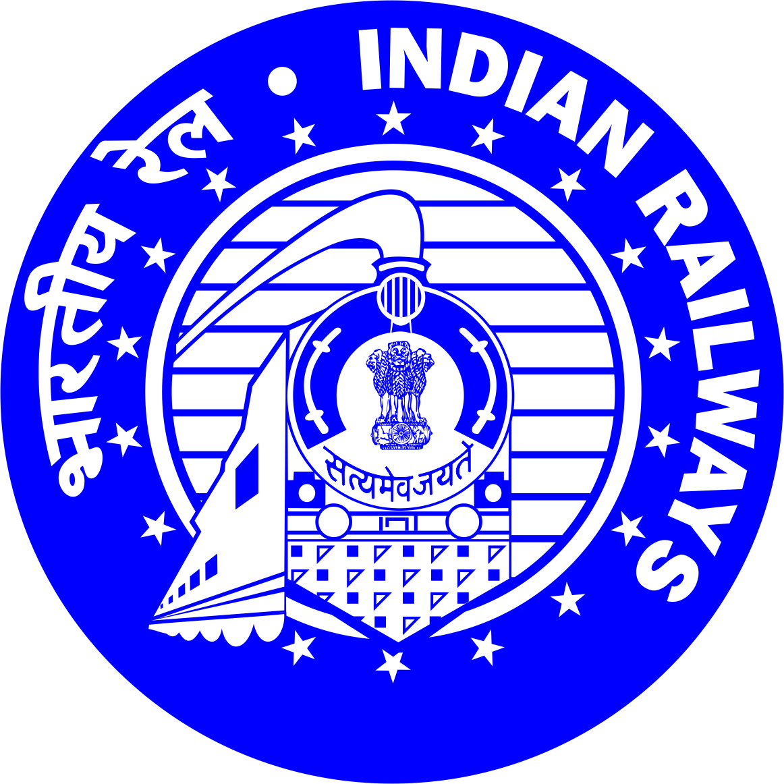 | 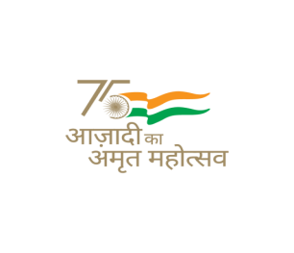  nf{k.k iwoZ e/; jsyos  SOUTH EAST CENTRAL RAILWAY

No. 2025/C/Chg./ATVM (III)/R Dt.- 12/08/2025.

Divisional Railway Manager (Commercial) S.E.C. Railway, Raipur Division for & on behalf of President of India invites applications in the prescribed format from interested Retired Group C & D Railway Employees & General Public, for appointment as Facilitators for issue of unreserved tickets through smart card based.
- Name of work: - Appointment of ATVM Facilitators at different stations for issue of unreserved tickets through smart card based.
- Date & time for submission of Application:- up to 15.00 Hrs. on 19/09/2025.
- Opening of Application Box: - At 15.30 Hrs. on 19/09/2025.
- Submission of Sealed Applications:- Application to be drop their sealed cover addressed to Sr. Divisional Commercial Manager/S.E.C.Railway, Raipur in the Application box kept in the box kept for this purpose in the office of Sr. Divisional Commercial Manager, DRM Office Complex, S.E.C.Railway, Near Wailtair Level Crossing Gate, RVH. Colony, Raipur (CG) up to 15.00 Hrs. of 19/09/2025.
For further details, eligibility criteria, Stations & complete details for the above work please contact office of the Sr.DCM/SECR/Raipur or refer/download application document & other details which is available on our website www.secr.indianrailways,gov.in.

Divisional Railway Manager (Commercial)
S.E.C.Railway, Raipur.

nf{k.k iwoZ e/; jsyos
SOUTH EAST CENTRAL RAILWAY

सं.2025/सी/dks-/एटीवीएम(III)/आर दिनांक- 12/08/2025

मंडल रेल प्रबंधक (वाणिज्यिक) एस.ई.सी. रेलवे, रायपुर मंडल, भारत के राष्ट्रपति की ओर से, स्मार्ट कार्ड के माध्यम से अनारक्षित टिकट जारी करने के लिए सुविधाकर्ता के रूप में नियुक्ति के लिए इच्छुक सेवानिवृत्त समूह सी और डी रेलवे कर्मचारियों और आम जनता से निर्धारित प्रारूप में आवेदन आमंत्रित करता है।
- कार्य का नाम:- स्मार्ट कार्ड आधारित अनारक्षित टिकट जारी करने के लिए fofHkUu स्टेशनों पर एटीवीएम फैसिलिटेटर की नियुक्ति।
2. आवेदन जमा करने की तिथि और समय:- 15.00 बजे तक दिनांक 19/09/2025 को।
3. आवेदन बॉक्स खोलना: - 15.30 बजे दिनांक 19/09/2025 को।
4. मुहरबंद आवेदन जमा करना:- इस प्रयोजन के लिए वरिष्ठ मंडल वाणिज्य प्रबंधक, डीआरएम के कार्यालय में रखे गए बॉक्स में रखे गए आवेदन बॉक्स में वरिष्ठ मंडल वाणिज्य प्रबंधक /एस.ई.सी.रेलवे, रायपुर को संबोधित अपने आवेदन पत्र को सीलबंद लिफाफे में आवेदन बॉक्स छोड़ दें। कार्यालय परिसर, दक्षिण रेलवे, वेल्टेयर लेवल क्रॉसिंग गेट के पास, आर.वी.एच. कालोनी, रायपुर (छ.ग.) समय 15.00 बजे दिनांक 19/09/2025 तक।
अधिक विवरण, पात्रता मानदंड, स्टेशनों और उपरोक्त कार्य के लिए पूर्ण विवरण के लिए कृपया सीनियर डीसीएम/एसईसीआर/रायपुर के कार्यालय से संपर्क करें या आवेदन दस्तावेज और अन्य विवरण देखें/डाउनलोड करें जो हमारी वेबसाइट www.secr.indianrailways,gov.in पर उपलब्ध है।

मंडल रेल प्रबंधक (वाणिज्यिक)
एस.ई.सी.रेलवे, रायपुर।

nf{k.k iwoZ e/; jsyos
SOUTH EAST CENTRAL RAILWAY
----------------------------------------------------------------------------------------------------------------------------------------------------
No. 2025/C/Chg./ATVM (III)/R Dt.- 12/08/2025.

Notification

Appointment of Retired Railway employee & General Public for working as ATVM facilitator over Raipur Division.
Sr. Divisional Commercial Manager, SECR/Raipur on behalf of president of India invites application from interested Retired Group C & D Railway Employees & General Public for engagement as ATVM facilitator for issue of unreserved tickets through smart card based Automatic Ticket Vending Machines upon fulfilment of certain conditions as under:-.
Eligibility conditions:-
- The engagement of facilitators shall be applicable to Retired Group C & D Railway Employees & General Public. He/She should be Retired Railway employee of South East Central Railway/Raipur Division.
- The employee should have retired in the normal course of superannuation or voluntary retirement. A copy of PPO certificate and service certificate to be enclosed with the application. Employees who have been dismissed, removed or compulsorily retired under DAR rules are not eligible and their applications will be rejected.
- Assistance to facilitator: - In terms of Commercial Circular No. 33 of 2019 dtd. 15.07.2019, Spouses and adult Children of retired railway employees may also be allowed to work as facilitators in addition to retired railway employees working as facilitates. The order of priority for engaging facilitator shall be as under :
a) Retired Railway Employee.
b) Spouse / Adult Children of Retired Railway Employee (only one person for one retired railway employee to be nominated by him / her).
Spouse/adult children of retired railway employee shall not have any claim for employment. An undertaking to this effect on legal paper should have to be submitted by spouse/adult children of Retired Railway employees.
- Facilitators will be entitled to work on rotational/shift basis in prescribed ATVM of each location.
- In case no response is received from Retired Railway employees, applications from General Public for engaging as facilitators will be considered.
- The applicant should be a resident of local district in which the station is located where ATVM facilitator is proposed to be engaged and not be under 18 years of age and should have passed at least Class – X exam

Application is available on website www.Indianrailways.gov.in., application shall be accepted in the office of Sr. Divisional Commercial Manager, South East Central Rly, Raipur between 10.00 hrs to up to 15.00 hrs on 19.09.2025. Application after completion of all required formalities will be processed for scrutiny and on fulfilment of all conditions;. Application received by the post shall not be accepted.
Applications received without fulfilling all the conditions stipulated in the application form and General conditions are liable to be rejected.
The Railway administration reserves the right to select/reject/terminate the services of any applicant and also to cancel the notification without citing any reasons.
Clarification regarding terms & conditions of the scheme may be obtained from the office of Sr. Divisional Commercial Manager, S.E.C.Railway, Raipur between 10:30 hrs to 17:30 hrs on working days.
Encl:
- Annexure “A”: Salient features of the scheme
- Annexure ”B”: Application form for engagement of ATVM facilitators (Retired Railway Employees)
- Annexure “C”: Application form for engagement of ATVM facilitators (General Public)
- Annexure “D”: List for engagement of ATVM facilitators.

Sr. Divisional Commercial Manager
SEC Railway, Raipur.

Annexure “A”

South East Central Railway Raipur Division

Engaging of ATVMs facilitators over Raipur Division

Salient features of the scheme:
- Eligibility Criteria for Retired Railway Employee:
- The retired Group C & D Railway employees of Raipur Division are eligible to be engaged as facilitator of ATVM for issuing unreserved tickets.
- The employee should have retired in the normal course of superannuation or voluntary retirement. Employees who have been dismissed, removed or compulsorily retired under DAR rules are not eligible and their applications will be rejected.
- Assistance to facilitator:- Spouses and adult Children of retired railway employees may also be allowed to work as facilitators in addition to retired railway employees working as facilitates. . (Only one person for one retired Railway employee to be nominated by him/her). An undertaking on legal paper should be submitted by facilitator that engaged Spouse/adult children shall not have any claim for employment in Railway.
- Facilitators will be entitled to work on rotational/shift basis in prescribed ATVM of each location.
- Multiple applications will be treated as invalid.
- The retired railway employee shall submit their application in enclosed format (Annexure-B).
- Both the ATVM Facilitator and the additional persons, if any, nominated by him to sell tickets shall be issued photo identity cards by this office and they must wear uniform and identity cards while on duty.
- Eligibility Criteria for General Public :
In case no response is received from Retired Railway employees, applications from General Public for engaging as facilitators will be considered.
The engagement of General Public as facilitators for ATVMs is subject to the following terms and conditions:
- The applicant should be a resident of local district in which the station is located where ATVM facilitator is proposed to be engaged.
- Applicant should not be under 18 years of age and should have passed at least Class – X exam. (Attested copy of proof to be attached).
- The applicant will also have to produce a police verification certificate from the Police Station serving his/her locality that he/she has no criminal record and no criminal case is pending against him/her before engagement as ATVM facilitator.
- Documents to be submitted for (For General Public) :-
- A resident certificate of local district in which the station (ATVM is located) where facilitator is proposed to be engaged.
- Pan Card & Aadhaar Card.
- The applicant should produce a medical Certificate issued by Government Hospital, or registered Medical Practitioner,stating that he is fit for active service and free from any Communicable diseases.
- Valid age proof and any government Boards issued educational marks memo.
- Copy of Education qualification certificate. (Minimum X class).
- Terms and conditions for General Public.
- The successful Applicant shall have to submit Deposit Rs.50,000/- for NSG – 1 & 2 and Rs.25,000/- for other categories of stations towards refundable Security Deposit to the Railway in the form of money receipt/fixed deposit/demand draft. On completion/termination of contract, pending dues will be adjusted from the Security Deposit and balance refunded to ATVM facilitator.
- The cost of ATVM, its maintenance, provision of lease line, up gradation, etc, will be borne by the Railways. The cost of electricity and space shall also be borne by the Railways. However, in case it is proved that ATVM has been damaged due to any act of omission/commission on the part of facilitator, the cost of repair will be recovered from him/her.
- While shortlisting candidates from general public for engaging as facilitator, in case retired Railway employees also express their willingness, preference should be given to retired Railway employees for engaging as facilitator.
- In case of large number of applications for engagement as facilitator, the selection will be based on the draw of lots in a fair and transparent manner in public.
- The applicant should submit an undertaking that after getting selected to act as ATVM facilitator, he/she shall complete the existing period i.e. up to 31/03/2026. In case the ATVM facilitator express inability to operate ATVM, after being engaged as ATVM facilitator, the security made by the ATVM facilitator will be forfeited.
- Documents to be submitted for Retired Railway employees: -
- Copy of PPO & copy of Identity proof issued by Personnel Department at the time of retirement.
- Copy of Pan Card & Aadhaar Card.
- Tenure:
The ATVM Facilitator will be engaged up to the two years i.e. 31.3.2027 from the date of commencement, or as decided by the Rly. Administration time to time.
F. Selection:
1. Applications for appointment as ATVM Facilitator in selected locations shall be submitted in the prescribed format.
2. Multiple applications from the same applicant, if any shall be rejected as invalid.
3. Accepted applications after scrutiny shall be sorted location wise and processed.
G. Termination of agreement:- The engagement will be terminated by serving a termination letter on the facilitator in case of the following omissions and commissions on the part of the facilitators:
- Sub-letting of the engagement, delegation of duty to any other person except to his / her spouse adult child (only one person as permitted by this office).
- Not manning the ATVM regularly.
- Not working on Versatile ATVMs (Co-TVMs) to educate passengers for atleast one hour per day.
- In case of complaint of excess charging.
- Acts of misbehaviour with passengers or with the Railway staff.
- Restarting /blocking the priority for Smart Card holders in use of the ATVMs.
- Committing frauds such as resale of tickets etc.
- The health condition of the facilitator does not permit him to discharge his duty effectively.
- Any other omission/commission on the part of facilitator which in the opinion of Railway Administration is detrimental to the interests of passengers and Railways.
- Violation of any of these Terms and Conditions.
H. Disabling Clause: - The engagement of an ATVM Facilitator Engaging does not grant any employment right within the Railway, the engagement is solely contractual and does not entitle the facilitators the benefits such as absorption in to Railway service, regularization of employment, bonus & Railway pass facilities etc. No claim in this regard shall be entertained. ATVM Facilitator shall keep Railway free form any liabilities in present or future.
- DELEGATION OF DUTY (NOT ALLOWED). :-
- The retired railway employee has to himself work as facilitator and he cannot delegate this to any other person except to his/her spouse/adult child as permitted by this office. (only one person for one retired Railway Employee).
- The general Public ATVM facilitator has to himself/herself work as ATVM facilitator and cannot delegate this to any other person, at any circumstances.
- Unauthorized, delegation of duties will lead to punitive action as well as termination of services with immediate effect.
J. Other Terms & Condition:-
- Only one application will be submitted by an applicant. Multiple applications will be summarily rejected.
- At stations where there is one ATVM, first preference for buying tickets shall be to passengers who buy for themselves i.e. through self-operation. “Facilitators” shall use the machine after self-operating passengers are done with the usage of the machine
- Facilitators will be given I-Card with photographs certified from Railway Officials. He/She shall wear this I-Card conspicuously in such a way that it can be seen/read by the passengers.
- Administration shall allow him/ her to operate at only on ATVM sanctioned. Facilitator will not work at the ATVM other than the ATVM for which he/ she is permitted to function unless permitted by competent authority.
- No remuneration will be paid to the facilitator by the Railways, except bonus given on every recharge of smart card. “The bonus on smart card recharge shall be @3% for journey up to 150 kms. The bonus for journey between 151 km and 500 km shall be admissible @2% and thereafter, bonus shall be given @1% for tickets issued for distances beyond 500kms shall be applicable for NSG 1, NSG-2 and NSG-3 category stations. For other categories of stations, the 3% commission is permitted only for travel on Suburban section and in Non suburban section the commission is available only for tickets up to 150Kms.
- Facilitators will be allowed to work for 07 days a week, after due permission.
- Working hours of facilitators shall be decided by CBS/SM. Only one facilitator shall be nominated to work in a shift and the CBS of concerned stations shall decide the duty hours of facilitators in accordance with the needs, so as to ensure that only one facilitator is available at any given point of time at a particular ATVM.
- Any act of overcharging or misbehaviour with the passengers shall attract withdrawal of permission to work as facilitator. Penalty may be imposed by the competent authority in case of any irregularity.
- The facilitators will purchase on smart card when he/she is selected and register the same with the Division. The recharge of smart card will be done by the facilitator as per his/ her own requirement.
- In case, the allotted smart card is lost, facilitator will purchase another smart card and get it registered with Divisional Office with an application form.
- Railway administration, with prior intimation can change the nominated ATVM allotted to facilitator permanently/ temporarily or may call the facilitator to work at station not nominated to him/ her.
- Facilitator will form a queue of passengers. The regular ATVM card holders/ passengers desiring to procure tickets on their own shall be allowed to take tickets without queue. Any complaint about disallowing smart card holders to purchase tickets from ATVMs shall also be viewed seriously.
- Facilitator will encourage passengers to use ATVMs and educate the handling of ATVMs.
- On every recharge of ATVM, bonus value is credited in the smart card. ATVM facilitators will retain the bonus value as their commission. No additional emoluments will be given apart from the bonus credited in the smart card. Bonus value may change as per policy guidelines of Railway Board. No claim on any account will be acceptable.
- Under no circumstance, the facilitator will permit any other person to issue tickets through his/ her smart card. Any such act will terminate the facility with immediate effects.
- Commencement and closure of work shall be reported to CBS/on duty supervisors and the same has to be recorded in the register kept for this purpose in the Booking Office. The commencing and closure number of ticket should also be recorded along with no. of tickets and amount. Facilitator will promptly advise the CBS regarding timely replacement of ticket rolls and failures of ATVM
- Competent authority (Sr. DCM) reserves the right to disengage any facilitator at any time without giving any notice.
- Railway employee given compulsory retirement/ dismissal as a result of any DAR proceedings will not be eligible for facilitator.
- As per instructions guidelines by Railway Board from time to time will be bound by the facilitator.
- In all cases including engagement, procedures for operation, transfer, termination etc, decision of the Sr. Divisional Commercial Manager, Raipur will be final and binding.
- All the engaged facilitator will be bound to carry out instructions/ circulars issued by Railway Boards/Railway Administration from time to time.
- Dusting and general cleaning of ATVMs will be the primary responsibility of the facilitator. Any system failure and requirement of ticket roll shall be reported promptly to the CBS/SMR, who in turn will take necessary action and get the ATVM rectified.
H. SUBMISSION OF APPLICATIONS:

- The application is required to be signed by the applying person himself. Each & every page of the application form should be signed.
- The application must be filled in ENGLISH or HINDI and all entries must be made by handwritten with the enclosure under to be kept in sealed cover Overwriting is not permitted.
- Retired Rly. Employee should complete the application form provided in “Annexure –B”, while General Public should use “Annexure- C” to fill out their application form.
- Failure to comply either of these conditions will render the application liable to rejection.
- Applications received through post/courier will be summarily rejected without any scrutiny.
- The applicant must obtain for himself on his own responsibility and at his own expense all the information which may be necessary for the purpose of filling the application and acquaint himself/herself with all local conditions, means of access to the work, nature of work and all matters pertaining thereto. The applicants are advised to visit the concerned station, Check the spot, train timings, traffic pattern before applying.
7. Selection of ATVM facilitator shall be done by Railway; the decision of the Railways will be final. Railways reserve its rights to reject any application without assigning any reason. No canvassing or correspondence in this regard will be entertained from unsuccessful applicants.

- 8. Railway will inform about appointment of ATVM facilitator to selected applicants
- only. No intimation will be given to rejected applicants.
9. The applicant must write on the top of the envelope in the bold and capital “Application for engagement of facilitator to operate ATVM at _________________ Station”. The sealed envelope should be dropped in the Application Box only to be kept in the office of Senior Divisional Commercial Manager/South East Central Railway/Raipur. Application will be received from 10.00 hrs to 15.00 hrs. of 19.09.2025 and after which no application will be entertained. & Application box will be opened on 15.30 at 19.09.2025 hrs.

<><><>

“Annexure B”
APPLICATION FORM FOR RETIRED RAILWAY EMPLOYEE FOR ENGAGEMENT AS FACILITATORS FOR ATVMS.
Paste a recent Passport size self attested photograph.

Name of the Retired Employee (in Block letters)
Father/Husband’s name
Designation at the time of retirement
Last Station/Office worked at
Department
Name of spouse/adult children with relation if required for assistance.
Pension A/C no.
PF no
Date of Birth
Date of retirement (DD/MM/YY)
Date of appointment ((DD/MM/YY)
Present residential address

Phone Number
Whether any DAR/Vig. case pending
Station for working as facilitator
Whether engaged/terminated as ATVM facilitator at any other station and other details and enclose copy of appointment /engagement order :
If Yes, mention the station name :
Whether the employee retired on : -Normal superannuation
- Voluntary retirement
If not due to normal superannuation, then please give details of mode of
Retirement :
I declare that all the information given above is true to my knowledge. I have read the terms and conditions and agree to abide by them, if selected. I hereby submit my application for appointment as Facilitator for ATVMs.

Place
Date: Signature of Applicant.

Note: Enclose a copy of Attested Residential Address Proof (Aadhar Card/Election Card/Passport), copy of Identity proof issued by Personnel Department at the time of retirement, 2(Two) copies of passport size photo.

<><><>

Annexure “C”
APPLICATION FORM FOR GENERAL PUBLIC FOR ENGAGEMENT AS FACILITATORS FOR ATVMs.
Paste a recent Passport size self attested photograph.

Name of the applicant (in Block letters)
Father/Husband’s name
Sex: (Male/Female/Others)
Date of Birth (with proof):
Education Qualification
Present residential address

Phone Number (Mobile and Landline if any)
Station for working as facilitator
Declaration:-
In the event that I am unable to operate the ATVM after being engaged as an ATVM facilitator. I am understood that security deposit deposited by me will be forfeited.

I declare that all the information given above is true to my knowledge. I have read the terms and conditions and agree to abide by them, if selected.
I shall not claim for employment in Railway other than the bonus value as considered by Railway Administration.

Place
Date: Signature of Applicant. (General Public)

Enclosures:-
Attached Age proof - Copy of PAN card/Voter ID/Aadhaar Card & any other ID issued by Govt. of India.
Attached Education Qualification (X passed copy).
Attached Proof of residence/address certificate is enclosed.
Medical Certificate stating fit for active service and free from any Communicable diseases.
Recent passport size photograph has been affixed.
<><><>

Annexure “D”

Sr. No | Station | Category | ATVM facilitator to be engage
1 | Raipur | NSG-2 | 03
2 | Bhatapara | NSG-3 | 01
3 | Tilda | NSG-6 | 02
4 | Hathband |  | 02
5 | Bhilai |  | 03
6 | Urkura |  | 03
7 | Maruada |  | 01
8 | Bhanupratappur |  | 02

<><><>

